Title: Educational Psychology Insights: How Productive Struggle Enhances Learning
Update:
In the learning sciences, one important area is productive struggle, which the course readings and videos emphasize as a driver of deeper learning. Productive struggle occurs when students tackle tasks that are challenging but achievable, encouraging them to think critically rather than just memorize steps.
Contribution of Educational Psychology:
Educational psychology explains that learning is most effective when learners work in their Zone of Proximal Development (ZPD) (Vygotsky, 1978), where tasks are just beyond what they can do alone but achievable with support. This balance of challenge and guidance develops persistence, problem-solving, and metacognition. As shown in the course videos, when students experience guided struggle, they learn how to approach challenges with confidence.
Evidence:
Research supports these insights. Hiebert & Grouws (2007) found that students engaging in productive struggle retained knowledge longer and could transfer skills to new contexts. This reinforces the idea that well-managed difficulty produces durable learning.
Interpretative Concepts and Theories:
- Scaffolding: Temporary supports that fade as students grow more independent.
- Self-Regulation: Planning, monitoring, and evaluating one’s own learning.
- Growth Mindset (Dweck, 2006): Viewing mistakes as opportunities for growth builds resilience.
Practical Example:
In a math lesson, instead of providing formulas, the teacher asks a challenging problem and offers hints or guiding questions. Students work in pairs to test strategies, make errors, and adjust their reasoning. Over time, they solve similar problems independently, demonstrating both mastery and confidence. This connects to the course discussion of how productive struggle strengthens both content learning and 21st-century skills like persistence and collaboration.
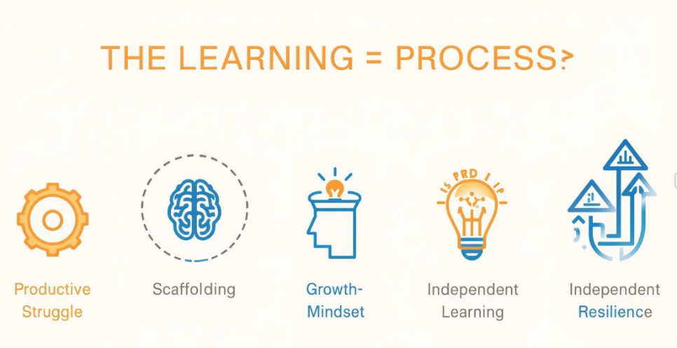
Flow of Learning Process:
Productive Struggle → Zone of Proximal Development (ZPD) → Scaffolding → Growth Mindset → Independent & Resilient Learning

Media Resource:
For a visual illustration, see the NCTM resource on Mathematical Tasks: Productive Struggle, which provides diagrams and examples that reflect Vygotsky’s ZPD in practice: https://www.nctm.org/Classroom-Resources/Illuminations/Mathematical-Tasks/
References & Links:
- Vygotsky, L. S. (1978). Mind in Society: The Development of Higher Psychological Processes. Harvard University Press.
- Hiebert, J., & Grouws, D. A. (2007). The effects of classroom mathematics teaching on students’ learning. In F. K. Lester Jr. (Ed.), Second Handbook of Research on Mathematics Teaching and Learning (pp. 371–404). Information Age Publishing.
- Dweck, C. S. (2006). Mindset: The New Psychology of Success. Random House.
- NCTM. (n.d.). Mathematical Tasks: Productive Struggle. https://www.nctm.org/Classroom-Resources/Illuminations/Mathematical-Tasks/

